You're Invited to come and hear
Special Guest Speaker,
Eddie Chumney
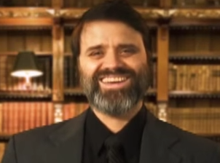
Glenforest School
Shabbat, April 29th
2:30 - 8:00 PM

Eddie Chumney is the founder of Hebraic Heritage Ministries Int'l. Eddie is a leading national and international speaker on the Hebraic Roots of Christianity. He is recognized as one of the foremost scholars in Hebraic studies. He inspires and motivates believers to more intense and devoted study of the Word of God like few can do.
From his studies, the God of Israel put upon Eddie's heart to start Hebraic Heritage Ministries Int'l in 1995. After learning about the Biblical Festivals and the two houses of Israel, Eddie began to learn and teach Bible prophecy from a Hebraic point of view which gives a deeper foundation to understand the "last days".
Eddie will take us through Biblical prophecies and how those are being fulfilled in our day. He will share from his in-depth study of the Word and the current events of what He believes is unfolding before our eyes. He will awaken us to recognize the signs and events so we can be "a light upon a hill" to the ones around us.
Eddie will have two teaching sessions during the day. We will have a covered dish supper between the sessions. Please bring your favorite 'kosher' covered dish. This will be a most enlightening day of worship and study.

